TRANING IN SOUTH FLORIDA
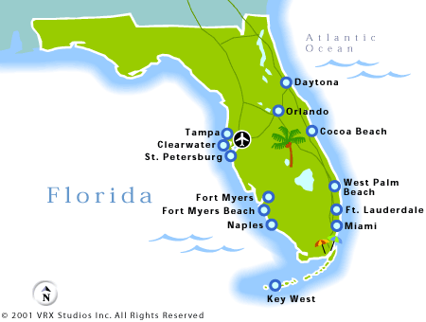

ACHA Behavioral Health Case Manager (MHTCM) CLASS

Monday – AUGUST 27, 2018 – 10 am to 4 pm
WHERE:
Best Western Hotel
1800 Palm Beach Lakes Blvd.
West Palm Beach, Fl. 33401

TRAINING REGISTRATION FORM
SOUTH FLORIDA

~ Print your name as you would like it to appear on your certificate ~

NAME: |  |  | TODAY’S DATE:
E-MAIL
COMPANY
PHONE 1 |  |  | PHONE 2:
REFERRED BY
CHECK APPROPRIATE BOX : |  | TCM

DATE OF CLASS: AUGUST 20th, 2018 * COST: $200.00

* Balance due by AUG. 27th 2018 Class Time.

FAX TO: (407) 440-4510

E-MAIL: W.CLEGG@helpingishealing.com

Office Number (407) 440-4509

